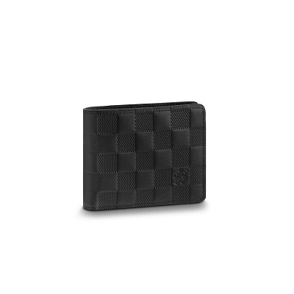

Slender Wallet for Men in Damier Leather

PRODUCT DETAILS

**- 4.3 x 3.5 inches**

**- Damier Infini Leather**

**- Cowhide Leather lining**

**- 8 credit cards slots**

**- 1 bill compartment**

**- Made in France or Made in Spain**